Renewable Home

Michael Dardis

COP 6931

University of West Florida

**Background of the Project**

Currently, the United States is one of the most heavy energy consumption users in the world. For environmental sustainability, and to save on individual costs, it's useful to implement a smart system for use in a home that can effectively utilize renewable energy and reduce overall consumption. For the scope of this project, the goal is to explore ways a utility system can use different energy inputs to help reduce a home’s energy consumption.

# Objectives

The objectives for this project would include using research techniques to discover methods of interpreting different renewable energy resources and using this information for calculating a new home energy use strategy for a residential building. In developing this application, storing useful information would include the user’s information. This includes their type of home, their energy consumption, and the amount of space that the residential space takes up. The client is home owner John Groves, and would include using his home structure to test the effects of renewable energy would have on his energy bill and consumption. This would assume local markets for specific types of renewable energy would be available. Dr. Lohr will act as mentor during this project and will guide project development throughout the building process.

# Project Statement

This project will be an energy calculator application that will determine how the use of renewable energy sources can be used in a particular home and show the economic impact. The system inputs will include a user’s home information, including the size of building in square footage. There will also be useful information about renewable energy resources and how the user can learn more if they want to follow through with a realistic implementation.

**Research Problem**

With a growing concern of climate change, pollution, quality of life in cities, and expansion of renewable energy technologies, more people are becoming interested in how this can be implemented into their everyday lives. [1] This project seeks to analyze the changes to a home’s energy usage and cost when being buffered with renewable energy sources.

**Justification**

In addition to climate change, overpopulations and energy shortages around the globe have become a problem. Adopting renewable energy sources and measuring the impact of the change can help with promoting the development of more green technologies. There are many benefits to adopting renewable energy in a home or in a business. This helps the home, and in turn the power grid by being more energy independent and self-sustaining.

For a home, having energy sourced by renewables can potentially lower the cost of energy usage, and provide a higher quality of life by using less pollution, thereby improving the air quality in some cases. There are already many different research teams looking at renewable energy in a macro sense for entire cities around the world. Wind turbines and solar farms are being constructed to power grids, and having this kind of energy could have a major impact on the future of energy costs.

**Deficiencies in project**

Due to the scope of the project, some deficiencies could include the use of simplified methods to give an overall assessment. Energy usage can vary day to day, and renewable energy gained can vary as well. The technology being discussed is still relatively new, and long-term research is still being conducted.

**Audience for the project**

The test home will be John, the client, but the audience can include any home, apartment, or office building users that are curious to see the economic gains of implementing renewable energy. There will also be useful links and information on how the user can find out more about each type of renewable energy presented. This feature can help spread awareness about renewables and how they can get involved with their community.

**Summarization of Research and Purpose of Project**

**Research Focus**

The questions that were explored during research included reviewing the different types of renewable energy resources available or currently being developed for the marketplace. In addition, research included finding the ecological and economic impacts of using these technologies. For the application itself, finding the best environment and platform were the challenges proposed. This also involved setting up a learning process to help with development of the project itself.

**Purpose Summary**

The purpose of this project is to develop a web application showcasing the variances in energy cost and usage when a residential home utilizes varies forms of renewable energy. The hope is also to bring awareness to sustainable energy practices by providing quick information links on each energy resource within the application.

**Going forward: Project Methodology**

The project for this application will follow the waterfall method. This involves first gathering the requirements for the project. This can include obtaining a client and objective for the project itself, and is followed by the design phase. This is done with a software design document, containing all the architectural specifications for the program. This makes implementation easier, and can be signed off by the client before the code itself is written. After development, thorough testing is done and user documentation is created for the final product.

**Literature Review**

Renewable energy is a vital part of transforming the energy industry and aid in the development of a more self-sustaining ecosystem for urban and rural environments. To see how technology can help the growth of renewables, information about how energy costs as it relates to renewables was researched. This was paired with practical techniques for developing a web application using MySQL and C#.

To start, the background on what the current state of renewable energy and the associated costs were reviewed. Renewable energy is a promising field with many benefits, including being “limitless, risk of climate alteration is reduced, and they also contribute to job creation.”(Armeanu[4]). The main sources of renewable energy being developed include solar, wind, hydroelectric, biomass, and geothermal. Of course, current technology and infrastructure can’t realistically allow for 100% renewables, as shown in that only 8% of energy production in the United States is using those renewable sources [10]. But, it is interesting and useful to look at long-term effects of implementation, and can hopefully spur on increased innovation in this field for use in residential homes.

One of the main hurdles discussed when implementing a renewable energy grid was the availability of that resources, and the means to store the excess energy. For the former, an example for availability was using South America as an example on how to increase infrastructure to provide a means of renewable energy [2]. Most of these countries for example, lie in the region known as the “Sun Belt”. This area contains some of the highest solar radiation, giving solar PV systems the optimal environment to thrive. Another way that was looked into for storage was using the pre-existing hydro dams that can be used as virtual batteries. Clearly, the use of certain energy sources must be tailored to the region, as efficiency must also be taken into account. Ultimately, the planning and infrastructure has to be supported by government entities, as the start-up costs of creating a renewable plant are currently high. The goal though, is that this cost will be offset in the longevity of the plant and the technology that will bring induvial costs low. However, the danger arrives in the form of oligopolies in the energy market that could result in the costs and subsidies granted not transfer to the consumer in savings [5]. This is caused by the few energy companies agreeing to a set price to charge, and because of the lack of competition in the industry that can bring prices lower.

For longevity purposes, the proposed application will show costs in ideal circumstances. For it to be realistically implemented across a geographic area such as the United States, major infrastructure projects need to be created for the use of a single grid. The trick in this case is to use energy where demand is not high, and be able to transport that unused energy to high-demand areas. This “smart grid” will be able to expand the range that renewable resources can be utilized, as in some areas, the sun may not be out, and wind could also be low. The problem is finding a way to store this excess energy, as Pierce points out, in that “A storage solution will allow us to store electricity when production exceeds demand and pump it back into the system when it is needed”[3].

To use these different energy sources, a power grid is used and can cover a wide range of infrastructure. To save cost-wise, a smarter grid would need to be able to utilize these different forms of energy and be able to handle them based on consumer demand on a per hour basis. The U.S. Energy Administration puts out statistics and analysis on energy usage and cost, and will be used to determine calculations for the home energy application that this project is based on.

In addition to the background of the topic, background information for the development of web design and using MySQL was obtained for project initiation. Simmons [6] lays out the key areas to focus on a web design project including the use of responsive design, using CSS, and includes best practices. As with design, bringing a web page that provides interactivity and takes into account the layout of the information on multiple screen sizes is important [7]. Bellomy [7] also mentions that different browsers can behave differently, and that they can be “unfriendly to novices, inconsistences in implementation of standards, and have set limitations that improve slowly [7]”. As with development with databases, MySQL is an open source solution to use alongside the application for data storage for the user and the important attributes that are tied to each source of renewable energy that will be used for the program. Rao [8] has provided clear instructions on how to create and manipulate a database with MySQL in “Everything You Need to Know about MySQL” [8]. This will be used as the starting point for the backend data handling for the project.

**Business Functions of the Project**

**Risk Assessment**

|  |  |  |  |  |  |  |
| --- | --- | --- | --- | --- | --- | --- |
| # | Risk Description | Category | Business Impact | Root Cause | Severity (1-5) | Priority (H,M,L) |
| 1 | Wrong time estimation | Schedule | Failure to estimate the time for different modules could lead to missed deadline or a lesser product | Failure to plan accordingly and gathering proper requirements | 5 | High |
| 2 | New technologies being used | Technical | Using a new technology has its own learning curve, and reliability is untested | Choosing MySQL and visual studio C# MVC are new technologies to the developer | 3 | Medium |
| 3 | Change in requirements | Technical | This could cause shifting deadlines and rework of functionality, and potentially throwing off schedule | User change requests or technological adaptations to issues that arise | 3 | High |
| 4 | Inconsistent productivity | Performance | Work performed needs to be consistent, or schedule could be thrown off, leading to missed deadlines | Procrastination on certain modules for the project could lead to the impacts mentioned | 3 | Medium |
| 5 | Rushing on design components | Performance | Rushing during planning or design can lead to reworking entire system, causing missed deadlines | Not gathering the correct amount of requirements, not detailing modules and functions enough | 4 | High |
| 6 | Miscommunication on design | Operational | This can lead to lack of desired functionality for final product | Lack of meetings, status of design, and gathering full requirements | 3 | Medium |
| 7 | Lack of training for developer | Operational | Can cause project slow down | Failure to view proper training materials that’s required for development | 2 | Low |
| 8 | Resources are not tracked properly | Schedule | Time, project assets, and budget hours would be effected. Incorrect metrics would be given | Not keeping detailed status updates, or updated project logs, or proper version control | 4 | High |
| 9 | Version control is not properly kept | Technical | Maintenance will be difficult, and not having backups for project artifacts will make it difficult for change adaptation | Lack to implement version control process like Git or other backup log at the beginning of development | 1 | Low |
| 10 | Failure to keep up to date project logs | Operational | Maintenance will be difficult, and not having backups for project artifacts will make it difficult for change adaptation | Failure to set up logging system in place | 2 | Low |
| 11 | Flaw in database design | Technical | Could lead to late or unfinished product. Added time to the development process will lead to more costs | Failure to plan accordingly during design phase | 4 | High |
| 12 | Flaw in object-oriented design | Technical | Could lead to late or unfinished product. Added time to the development process will lead to more costs | Failure to plan accordingly during design phase | 4 | High |
| 13 | QA diagnostics fail to catch system vulnerabilities | Technical | Exposed code or vulnerabilities could lead to denial of service or system failures. Bugs in code can also lead to functionality failure, leading to increased costs for maintenance | Improper or lack of testing methodologies set up during design and implementation phase | 3 | Medium |
| 14 | Failure to provide user training | Operational | If user is not enabled to use the program, then client won’t accept the final product | Lack of training materials or user tutorial on how to use the program | 3 | Medium |

Figure 1. Risk Assessment

**Risk Mitigation Strategy**

During the Planning and design phases, many of the risks listed can be mitigated or avoided. To avoid flaws in design, proper planning and elicit requirements can prevent mistakes from being developed in the program. Establishing a version control system and thorough weekly status reports can help with project logging and creating backups to reference when creating additional functionality modules.

Some of these risks can’t be avoided, such as changing requirements. Often times, requirements may be adjusted or change over time to accommodate the client or user. To mitigate this, there will be some “flex” hours added to the overall project timeline. The timeline will incorporate and expect changes or missteps in design, but if these risks don’t come to fruition, then the project’s only difference is finishing earlier.

There are some components that can be added to the project that can reduce the chance of risk fruition. For changing requirements, having a clear version control system and logging mechanism in place can help with tracking of work performed throughout the project lifecycle. To help with a new development environment or program, having clear test documentation and the use of a user manual can ease the deployment of the built system.

**Planning and Inventory Assessment**

For the project to be completed, research on the chosen topic had to be done. This included the development environment and an assessment on the methodology chosen for the solution to the problem. In this case, it involved finding a suitable calculation that would be used for showing the different effects of using renewable energy sources.

**Set-up Functions and Inventory Assets**

Setting up the project involves using a budgeted schedule showing the hours spent for the project. This can help with project management and provides a clear and easy way to see the progress of the project. For this environment, the development environment requires various hardware and software requirements. For hardware, a laptop and access to the internet would be the main items to use. For software, the development environment includes using Visual Studio using the MVC framework with the C# programming language for the functionality. For the client-side, understanding HTML, CSS, and the various using of JavaScript and third party libraries in JQuery can help with usability.

**Architecture Strategy**

The project itself will be guided using carefully detailed software design documentation. Using this document, the specifications include data flow diagrams, database structure, and the information on the different classes that will be used. For quality assurance, thorough testing will be used along with use-case scenarios to aid in deployment.

**Personnel**

Project status reports will be shared with the client via email, with major milestones (such as end of the semester) to be done in face-to-face meetings showing a demo or portfolio of work completed. The personnel involved include Michael Dardis as the developer, John Groves as the client, and Professor Lohr as acting mentor to monitor the progress of the project.

**Business Processes**

Some business process that are effected by the project include planning and gather requirements. These are the initial steps of the project and will utilize a calendar of project milestones to help keep the project on track with the proposed set deadline. As with planning, designing is a major part of the starting phases of a program. This kind of documentation includes the program’s database and a class diagram structure. During development, progress reports will monitor and track the changes that are occurring. Near the end, verification and validation will be important to make sure all planned functionality of the program are implemented and the client will be able to sign off on the project.

**Budgeted Hours for Project**

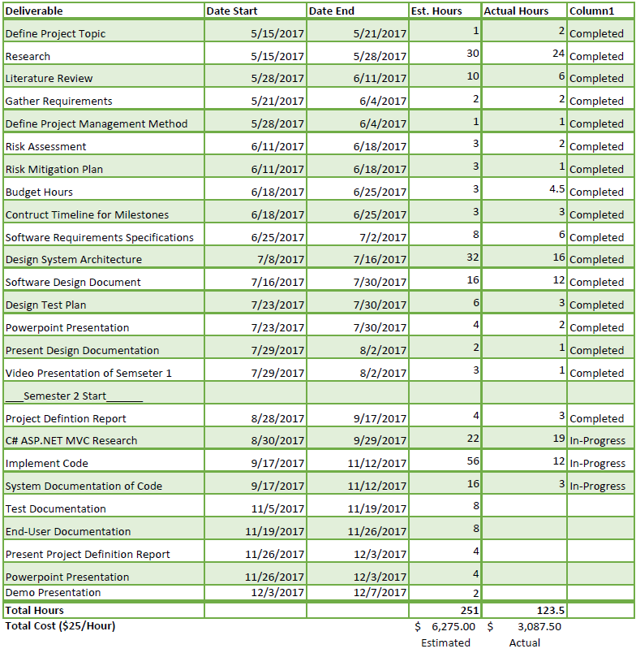

References

[1]Amin, Adnan Z. "How renewable energy can be cost-competitive." UN Chronicle P8 52.3 (2015): 8-11. UWF Libraries. Web. 4 June 2017.

[2]Bogdanov, Dmitrii, Pasi Vainikka, Christian Breyer, and Larissa Barbosa. "Hydro, wind and solar power as a base for a 100% renewable energy supply for South and Central America." PLoS ONE 12.3 (2017): 1-28 EBSCOhost. Web. 4 June 2017.

[3]Pierce, Alan. "Building a Smart National U.S. Power Grid." Tech Directions 68.9 (2009): 10-11. EBSCOhost. Web. 4 June 2017.

[4]Armeanu, Daniel Ştefan, et al. "Does Renewable Energy Drive Sustainable Economic Growth? Multivariate Panel Data Evidence for EU-28 Countries." Energies (19961073), vol. 10, no. 3, Mar. 2017, pp. 1-21. EBSCOhost, doi:10.3390/en10030381.

[5]Acemoglu, Daron, et al. "Competition in Electricity Markets with Renewable Energy Sources." Energy Journal, vol. 38, 2017 Special Issue 1, pp. 137-155. EBSCOhost. Web 4 June 2017

[6] Simmons, C. Instant Responsive Web Design : Learn the Important Components of Responsive Web Design and Make Your Websites Mobile-friendly. Birmingham, UK : Packt Publishing, 2013

[7] ]Bellomy, Ian1. "The Grain of the Browser: What Designers Should Know about the Craft of Web Design." International Journal of Visual Design, vol. 11, no. 1, Mar. 2017, pp. 1-15. EBSCOhost

[8] V. N., Rao. Everything You Need to Know about Mysql®. BrainMass Inc, 2012. Need to Know Series. EBSCOhost

[9] "Electric Power Monthly." U.S. Energy Information Administration - EIA - Independent Statistics and Analysis. U.S. Energy Information Administration, Mar. 2017. Web. 11 June 2017. <https://www.eia.gov/electricity/monthly/>

[10] Rozenblat, Lazar. "Your Guide to renewable Energy." Renewable Energy Sources: Cost Comparison. N.p., n.d. Web. 11 June 2017. <http://www.renewable-energysources.com/>